Order Data Report
Introduction
This report investigates a comprehensive dataset of automotive sales transactions, detailing attributes such as Order ID, Order Date, Ship Date, Customer Details, Product Information, and Sales Figures. The main goal is to extract actionable insights to enhance decision-making and promote business growth within the automotive sector.
The analysis examines sales data across various US states, segments, categories, and sub-categories to pinpoint key trends, top-performing segments, and potential growth areas. By evaluating sales performance by region, customer demographics, and product categories, the report identifies successful segments and opportunities for expansion or improvement.
The insights gathered will be crucial for automotive industry stakeholders, including sales managers, marketers, and executives, aiming to optimize sales strategies, improve customer satisfaction, and boost revenue. For instance, recognizing high-performing regions can guide resource allocation, while understanding customer preferences can lead to more precise marketing efforts.
Overall, this report delivers an in-depth look at the automotive sales environment, providing essential insights for strategic planning and operational decisions. This detailed examination supports growth and enhances competitive advantage in the automotive market.
Questionnaire
1. Compare all the US states in terms of Segment and Sales. Which Segment performed well in all the states?
2. Find out top performing category in all the states?
3. Which segment has the most sales in the US, California, Texas, and Washington?
4. Compare total and average sales for all different segments?
5. Compare the average sales of different categories and subcategory of all the states.
Analytics
Q1.Compare all the US states in terms of Segment and Sales. Which Segment performed well in all the states?
ANS: After analyzing sales and segments across all states, California emerged as the leader with sales totaling $222,419.05. The Consumer segment performed exceptionally well in every state, achieving total sales of $1,148,060.531. This indicates California's strong market presence and the widespread success of the Consumer segment nationwide

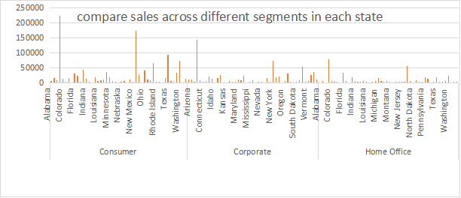
Q2. Find out top performing category in all the states?
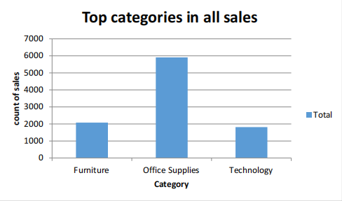
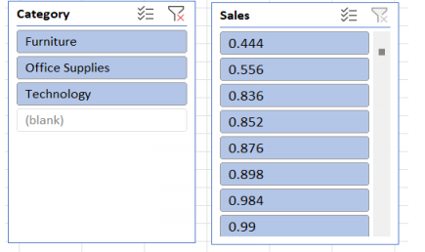
ANS: Office Supplies led all states with 5,909 sales, followed by Furniture (2,078) and Technology (1813).
Q3. Which segment has most sales in US, California, Texas, and Washington?
ANS: Filtering the states for the total sales count and showing the percentage of distribution through pie chart. The consumer segment has the most sales in US, California, Texas, and Washington.

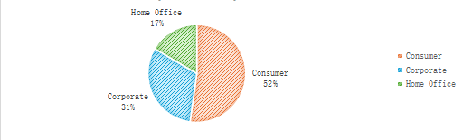

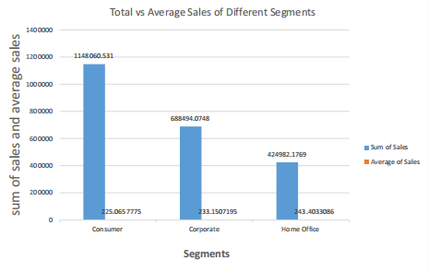
The distribution of sales among different segments in US, California, Texas, and Washington
Q4. Compare total and average sales for all different segments?
ANS: The Consumer segment shows the highest average sales at 1,148,060.531, while the Home Office segment has total sales of 243.40. Analysis reveals that total sales in all three segments exceed the average sales.

Q5. Compare average sales of different categories and subcategory of all the states.
ANS: The analysis of the Order Sales dataset revealed that among Furniture, Office Supplies, and Technology categories, the average sales of Technology significantly surpassed those of the other categories.
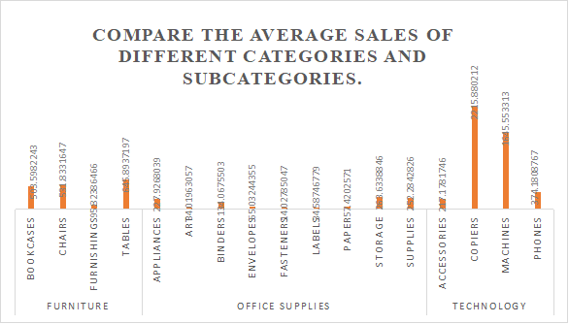

Conclusion and Review
The sales data analysis within the automotive industry reveals key insights. California leads in sales volume, with the Consumer segment performing strongly nationwide. Office Supplies is the top-performing category, followed by Furniture and Technology, reflecting consumer preferences. The Consumer segment consistently dominates sales across the US, especially in California, Texas, and Washington. The analysis also shows higher average sales for the Consumer segment compared to the Home Office segment. These findings offer valuable guidance for optimizing sales strategies, enhancing customer engagement, and driving business success in the automotive industry.

Regression
SUMMARY OUTPUT
Regression Statistics
Multiple R | 0.000434
R Square | 1.88E-07
Adjusted R Square | -0.0001
Standard Error | 625.334
Observations | 9789
ANOVA
 | df | SS | MS | F | Significance F
Regression | 1 | 721.1637 | 721.1637 | 0.001844 | 0.965747
Residual | 9787 | 3.83E+09 | 391042.6
Total | 9788 | 3.83E+09
 | Coefficients | Standard Error | t Stat | P-value | Lower 95% | Upper 95% | Lower 95.0% | Upper 95.0%
Intercept | 230.5863 | 12.63999 | 18.24261 | 3.83E-73 | 205.8093 | 255.3633 | 205.8093 | 255.3633
X Variable 1 | -9.6E-05 | 0.002235 | -0.04294 | 0.965747 | -0.00448 | 0.004286 | -0.00448 | 0.004286

Descriptive Statistics:
